Analysing slogans
Company | Slogan
De Beers Diamond Company | A Diamond is Forever
Nike | “Just Do It
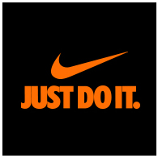

This deceptively-simple advertising slogan was launched by the De Beers Diamond Company in 1938 as the headline for what would become one of longest-running marketing campaigns of all time. Those four little words - a diamond is forever - suggest a sense of timeless romance and tie that romance to the diamonds that De Beers sells. The De Beers Diamond Company remains one of the largest diamond suppliers in the world, possibly because of this solid, sparkly slogan.

In 1988, a struggling sportswear company introduced this memorable line into its advertising and soon catapulted to the front of the pack. The company is called Nike. This quality slogan brims with attitude and captures the defiant and determined mentality that's required of successful sports stars. "Just Do It" is a bold statement that inspires athletes to work harder, a no-nonsense call to action that audiences instantly associate with Nike's products and accessories.

